# **Chapter 01, Python Programming basics lab**

## Objective

In this lab you'll use Visual Studio to create a Python application.

You will as a user input values using keyboard and display information.

You'll also use casting to convert strings to integers and floats.

**Duration:** 30 minutes. Please note there are three parts in this lab.

## Part 1 - Display Hello World!

## Objective

In this lab you'll use Visual Studio to create a Python application. Your code will display text to console. You'll then create two variables and display them within a sentence.

1. Start Visual studio and create a Python application.   
   Name this application as **Lab1** and take a good note of where it's saved.

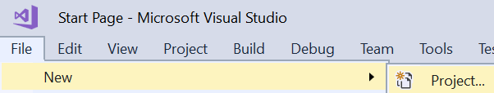

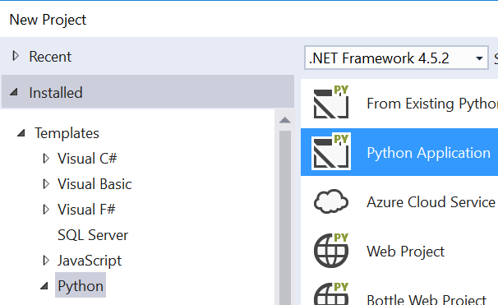

Note: If the option is not available, please follow the instruction below in steps a & b:

1. Open Visual Studio and then click Tools ⏵'Get Tools and Features…'

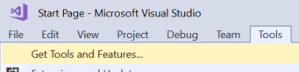

1. Select Python from the list and then click the Modify button.

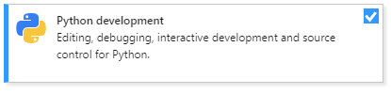

Note: You'll have to close the Visual Studio application because the Installer needs to modify it.

1. Type the following text in the code page that is open:   
   **print('Hello World!')**
2. Press **ctrl-s** to save.
3. Press the **F5** key to run.
4. When the program stops running, press **ctrl-F5** to run in non-debug mode.  
   Please note that it runs much faster.

We will discover the debugging feature of the development environment at a later date.

## Part 2 - Display a message using variables

1. Create two variables to hold someone's name and age.   
   In the code window, just below the last print() statement, type:

**username='Bob'**

**age=32**

**print(username,'is',age,'years old')**

1. Press **ctrl-s** to save
2. Press the key **F5** to run
3. Stop running the code and make the following changes.
4. Modify your code to use the '+' character to add strings

**username='Bob'**

**age=32**

**print(username+'is'+age+'years old')**

1. Press **ctrl-s** to save
2. Press the key **F5** or **ctrl-F5** to run. **ctrl-F5** runs a lot faster because it runs in non-debug mode (seen later).
3. Does the output look right or strings are stuck together. That's what + and strings does!

Modify the print statement by inserting three spaces in the strings like:  
**print(username,' is '+age+' years old')**

1. Save and run your code

**Please do not close this application. You'll add more code pages in part 2**

## Part 2 – Get user input

## Objective

In this lab you'll add a new code page to the Lab 1 application.  
You will also input values using keyboard.

### Instructions

1. Add a new code page to your project.   
   Right mouse click on the project's name and then add a new item as seen below:

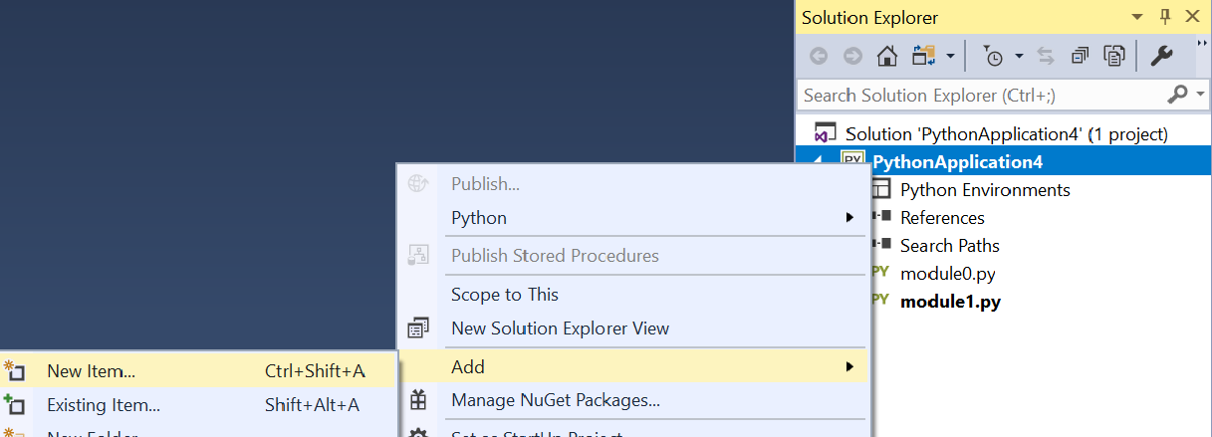

1. Select the  option and then give the file a suitable name.
2. You'll need to make this page as your start up page.   
   Right mouse click on the file name and then click the **'Set as startup file**' menu as seen below:  
     
   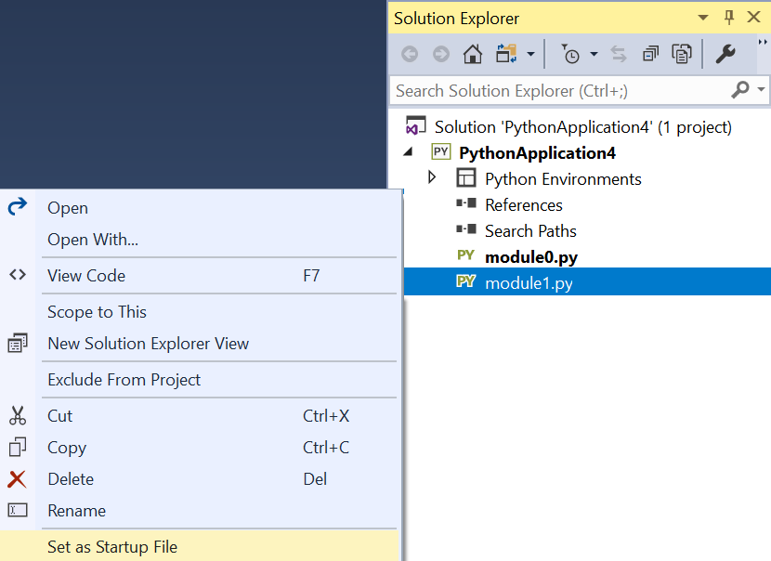
3. Write the following code to get the username and age by using the keyboard.  
    **username=input('Please enter your name')**

**age = input('Please enter your age')**

**print(username,'is',age,'years old')**

1. Save and run your code.

## Part 3

## Objective

In this lab you'll practice casting variables.  
You will input text values using keyboard and cast (convert) these into numeric types.

You'll input the length and width of a rectangle and calculate the area and perimeter of the rectangle.

### **Step by step instructions**

1. Add a new code page to your Lab 1's project and make it the startup file.   
   **Tip:** Right mouse click on the project's name and then add a new item as seen in part-2.
2. Input the length of the first side of a rectangle.
3. Use a suitable variable name such as ***length***.   
   You must cast (convert) the text you input to an integer type (int)

**Tip:** Please review the example code on the slides if you're not sure how to achieve this.

1. Inputs the length of the second side of the rectangle.

Use a suitable variable name such as ***width***.  
Again, cast the input text to an integer type (int)

1. Calculates and display the perimeter of the rectangle.
2. Calculate and output the area of the rectangle.
3. Save and run your code.

**\*\* End**